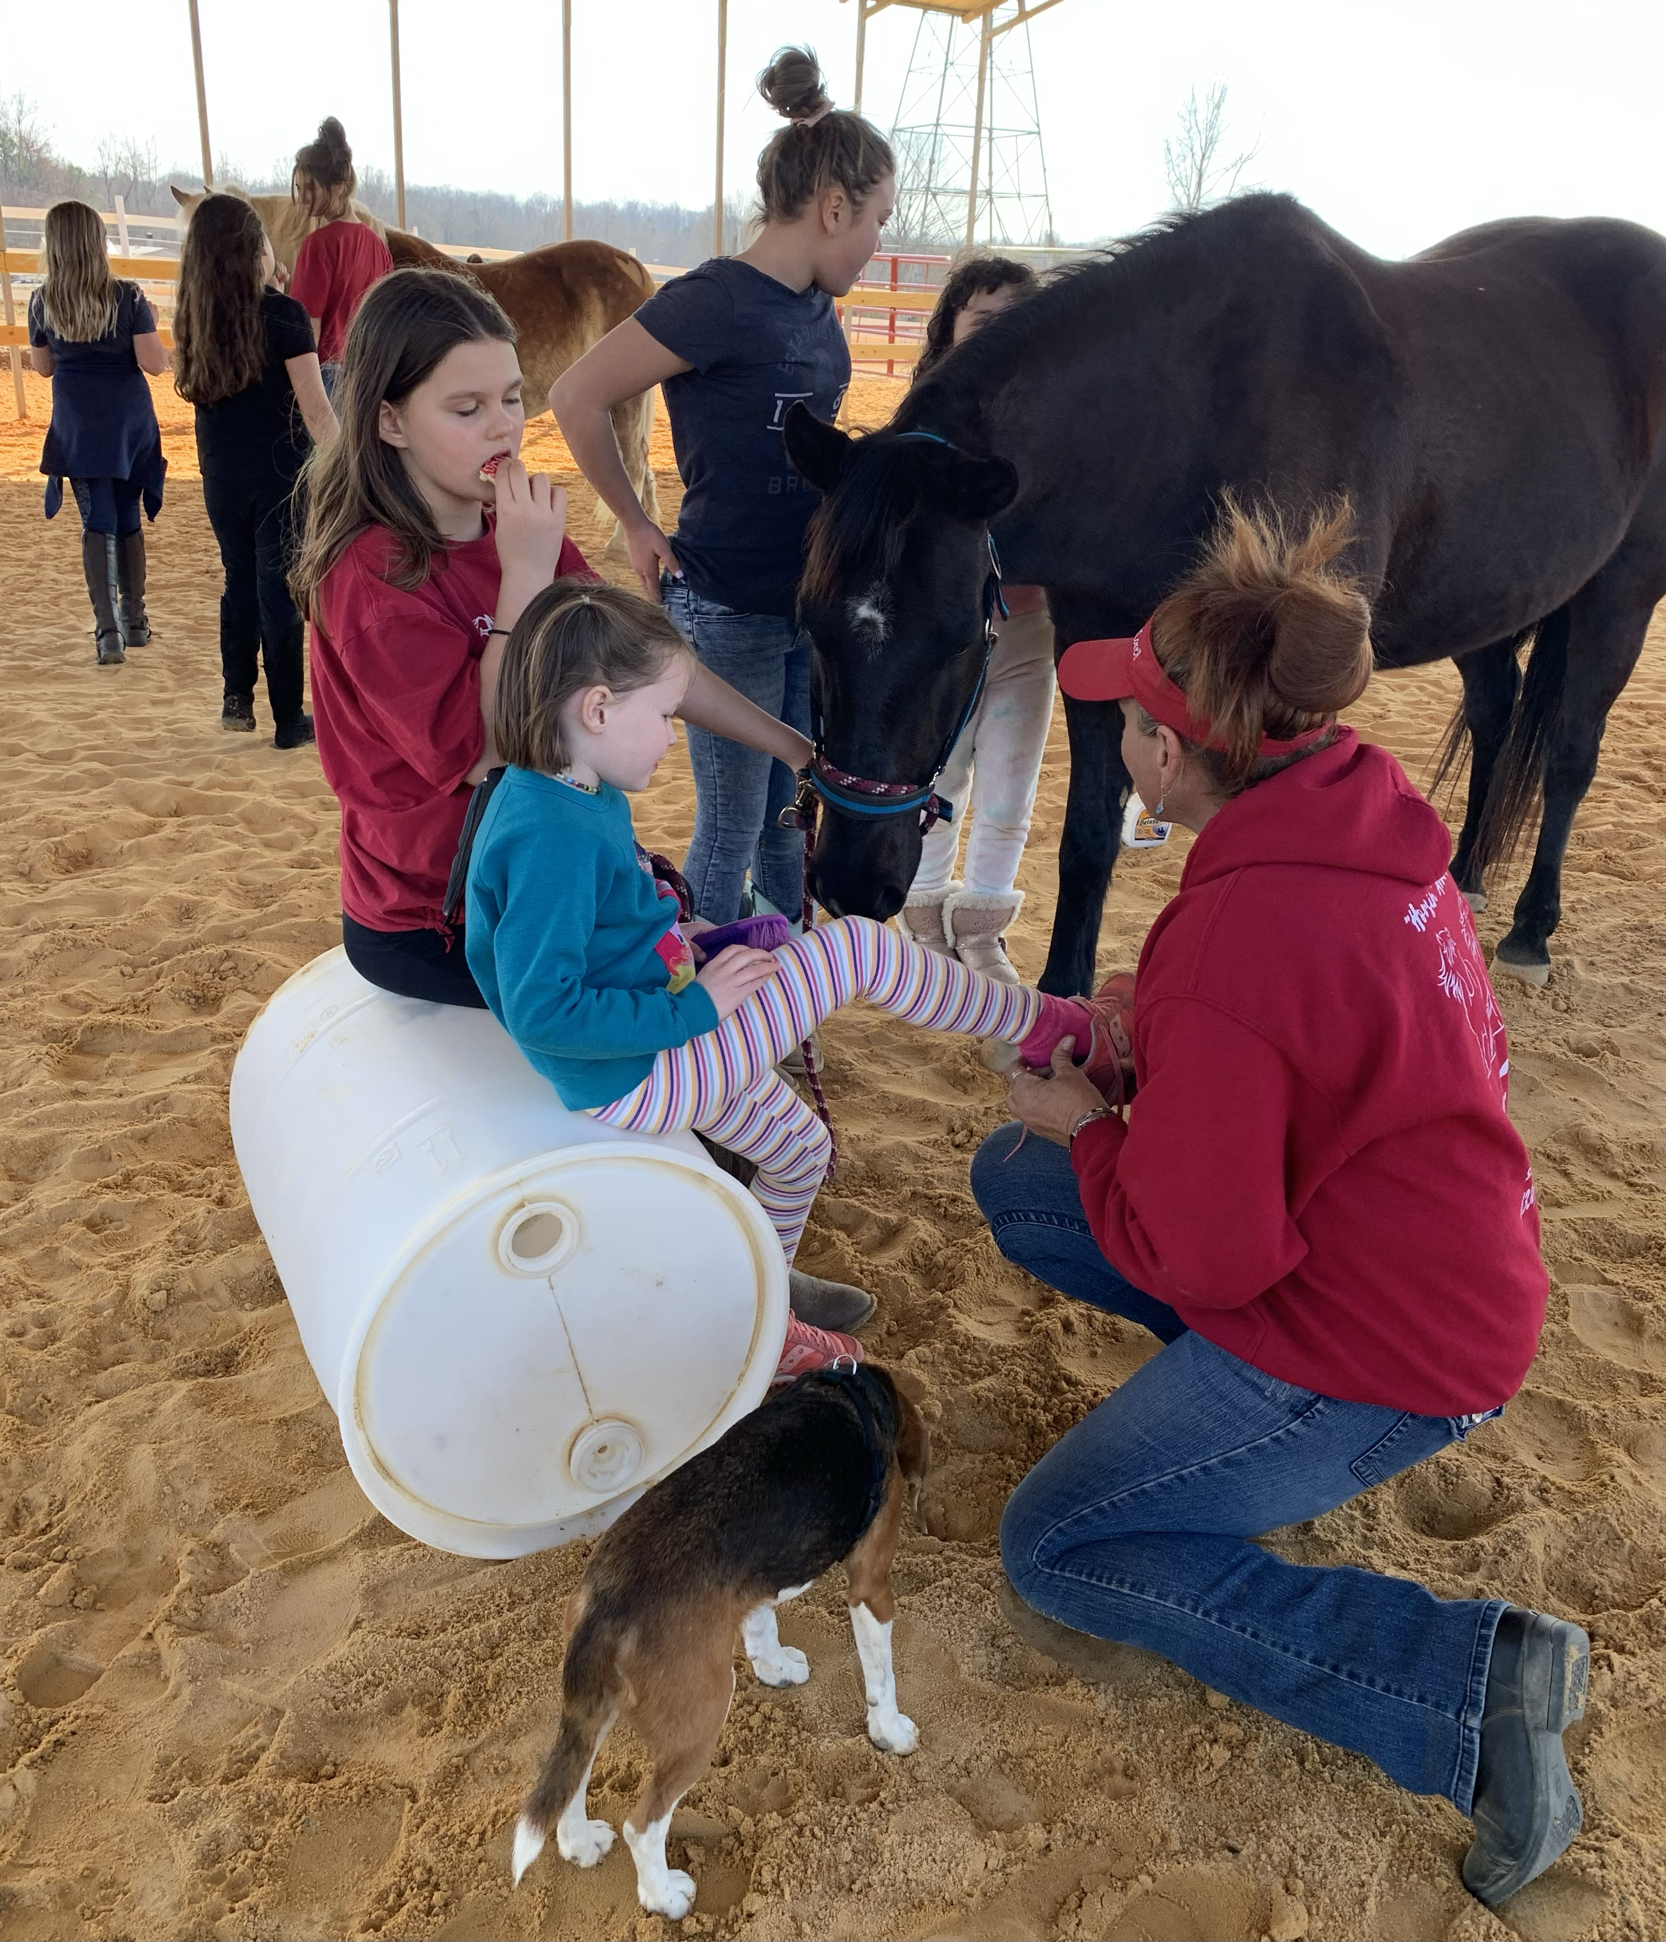 |  | Fether Morrow  Manager/ Trainer/Owner Big Creek Equestrian  Home at Stay Awhile Stables,
Profile  Fether is a lifelong horse person who has pursued her passion for horses professionally. Raised in a working cattle farm family, in Arkansas, with a long family history of ranching, the proper horse care , stable management, breeding as well as riding under almost any conditions imaginable are essential functions for survival of the business, the staff and the animals in their care. Riding, working and care is a partnership between the horse and rider. This partnership is critical to the safe and efficient operation of any horse centric business whether its cutting cattle on the Morrow Family Cattle Farms or as Guide at the nationally acclaimed OK Trading Post , safely leading novice riders on remote mountain trails. Knowing the physical capabilities of both the horse and rider is a skill that only a trained and experienced horse person like Fether can gain through her lifelong experience in all these aspects. Whether the title is wrangler, groom, trainer or rodeo bull rider, one thing is in common…safe care and handling of a very large, free will animal in the performance of a task, either for work or pleasure.  Fether brings this vast skill of knowing the horse and rider to her current position as resident manager and trainer at Stay Awhile Stable. Her incremental step by step approach to instruction is best described as teaching physical literacy for both the rider and their equine partner. This expertise comes from her 3 decades of hands-on experience  Contact  PHONE:  336-865-3733  WEBSITE:  Bigcreekequestrian.com  Email:  bigcreekequine@gmail.com  Fether@stayawhilstables.com  Hobbies  Everything horse |  | Career Experience and HighLights  5 years – Owner Operator Big Creek Equestrian  3 Years - Animal Laboratory Tech Wake Forest Baptist Hospital, NC  4 years -Jonny Lucas and Sons Stables – Saddlebreds  20+ Years - Morrow Family Cattle Farms  5 Years – Mountain Guide and Guest Services representative  15 years- Wrangler  15 Years – Rodeo and event riding  2021-Present - Integral member of start up team during planning, lay out and construction at Stay Awhile Stables creating and managing the Camps, Private lessons and Training of Clients  Background Relevant Experience  Fether was always active in High School programs from Leadership to the Arts. She was a contributor to local Art Shows and the President of the Class. This experience allows her to connect to her young riders and most imporatnty create that little extra touch that produces the child and the pony experience. The barn art is on display around the shed row and arena. Starting with the name, Stay Awhile Stables, the single focus is to form a community of people with the passion for horses and the joy this union brings. Her relevant experience is priceless and provides the vital student connection. As a 5-year-old girl watching a rodeo from the press box as her Grand Dad announces, or ropes from one of his many champion “Leo” colts, to achieving status as a wrangler, mountain tour guide or navigating the rigors of an international level show barn as a groom/ trainer, she knows what her students as well as the horses are “feeling”. This “feeling” is the basis of Fether’s instructional system that is designed to “get your hands dirty and boots dusty and learn literally from the ground up. The lessons are differentiated based on skill from a novice child or senior who has never ridden before to the advanced reschooling of a former Race Horse , (OTTB) or turning an abused show horse into a lesson horse. The results are an enjoyable union of horse and rider at the level they both meet. In horse terms, Fether will never over face a horse, or its rider and the experience will last a lifetime. Advanced instructional services are obtained through her extensive network of visiting clinicians or trailer in clinics, and it is all under the roof at Stay Awhile Stable. We simply desire to share with others the Passion and Enjoyment we have for this thing called horses.

